Software Design Document
Quiz App



Submitted by
Tanzeel Ur Rehman (S23BINFT1M01099)

Submitted to
Mr. Suleman Shah

Department of Information Technology
Faculty of Computing
The Islamia University of Bahawalpur

Summery
This Software Design Document (SDD) presents the design and architecture of the Quiz App for Students, a mobile learning application developed to help students assess and improve their knowledge through interactive quizzes. The system provides a user-friendly platform where students can register, log in securely, participate in subject-based multiple-choice quizzes, and receive instant feedback on their performance. The application is designed to support self-paced learning while encouraging continuous improvement through performance tracking and competitive ranking features.
The design of the system focuses on simplicity, scalability, usability, and reliability. The application follows a client-cloud architecture in which the Flutter mobile application serves as the front-end interface, while Firebase services provide authentication, database management, and cloud storage capabilities. User information, quiz categories, questions, quiz attempts, results, and leaderboard data are managed through Firebase Firestore or Realtime Database. Additionally, the system integrates the OpenAI API to support AI-powered quiz question generation, ensuring that quiz content remains fresh, relevant, and continuously expandable.
The system architecture consists of several major modules, including User Management, Quiz Management, Quiz Attempt and Evaluation, Performance Tracking, Leaderboard Management, and AI Question Generation. These modules work together to provide a seamless learning experience. Secure authentication mechanisms, efficient data storage, timer-based quiz execution, automatic score calculation, and result visualization are incorporated into the design to meet both functional and non-functional requirements.
Special attention has been given to security and maintainability. Firebase Authentication ensures secure user access, while database security rules protect sensitive information. The modular design approach allows future enhancements such as multiplayer quizzes, advanced analytics, personalized recommendations, and additional learning features without requiring significant architectural changes.
Overall, the proposed design provides a robust, scalable, and efficient solution for digital learning and assessment. By combining modern mobile technologies, cloud-based services, and AI-powered content generation, the Quiz App for Students aims to enhance student engagement, improve knowledge retention, and provide an effective platform for continuous academic development.

Table of Content

Contents
Table of Content 3
1. Application Architecture 5
1.1 Architectural Design 5
1.2 Process Flow / Representation 6
1.3 Design Models 7
1.4 Data Design 9
2. Data Model Schema 10
2.1 User Entity 11
2.2 Quiz Category Entity 11
2.3 Question Entity 12
2.4 Quiz Attempt Entity 13
2.5 Result Entity 13
2.6 Leaderboard Entity 14
2.7 AI Generated Question Entity 14
2.8 Overall Relationship Summary 15
3. User Interface 17
3.1. Design Philosophy & Niche 17
3.2. Visual Assets & Guide 17
3.2.1. Color Palette 17
3.2.2. Typography & Fonts 18
3.3. Responsive Layout & Screen Size Constraints 18
3.4. Detailed Screen Layouts & Data Explanation 18
3.4.1. Sign In / Authentication View (UC001 & UC002) 18
3.4.2. Home Dashboard & Category Selection View (UC003) 18
3.4.3. Active Quiz Session View (UC004) 19
3.4.4. Quiz Result Summary View (UC005) 19
3.4.5. Quiz Review View (UC006) 19
3.4.6. Quiz Performance History View (UC007) 19
3.4.7. Global Leaderboard View (UC008) 19

- Application Architecture

1.1 Architectural Design
The architectural design of the Quiz App for Students is developed to provide a scalable, secure, and user-friendly platform for interactive learning and knowledge assessment. Following the principles of Object-Oriented Design (OOD), the system is divided into multiple functional modules, each responsible for a specific set of tasks such as user management, quiz management, result processing, performance tracking, leaderboard management, and AI-based question generation.
The application follows a multi-tier architecture, ensuring clear separation between the presentation, business logic, and data management layers. This layered approach improves maintainability, scalability, and system performance while allowing future enhancements with minimal impact on existing functionalities.
The presentation layer consists of a Flutter-based mobile user interface that enables students to register, log in, browse quiz categories, attempt quizzes, view results, monitor performance history, and access leaderboard rankings. The interface is designed to be intuitive and responsive, ensuring a smooth learning experience across different Android devices.
The business logic layer handles the core functionalities of the application, including quiz session management, timer control, answer validation, score calculation, result generation, leaderboard updates, and performance analysis. This layer also manages communication with external services and implements application rules to ensure accurate and consistent operation.
The data layer utilizes Firebase services, including Firebase Authentication for secure user management and Firebase Firestore (or Realtime Database) for storing user profiles, quiz questions, quiz attempts, scores, and leaderboard information. The system also integrates with the OpenAI API to support AI-powered question generation, enabling the creation of dynamic and updated quiz content. Security mechanisms such as Firebase Security Rules and secure API key management help protect user data and maintain system integrity.
Overall, the architectural design provides a flexible, reliable, and secure foundation for the Quiz App for Students. By leveraging modern technologies such as Flutter, Firebase, and OpenAI API, the system supports efficient quiz management, real-time performance evaluation, and continuous content enhancement while adhering to contemporary software engineering best practices.

1.2 Process Flow / Representation
The process flow of the Quiz App for Students is designed to efficiently manage quiz activities, user performance evaluation, and learning progress tracking within a mobile learning environment.
The process begins when a student registers or logs into the application using secure authentication services. After successful authentication, the user accesses the dashboard and selects a quiz category based on their area of interest or study. The system retrieves the relevant quiz questions from the Firebase database and initiates a quiz session with a predefined timer.
During the quiz, the student answers multiple-choice questions, and the system records each selected response. The timer continuously monitors the remaining duration and automatically submits the quiz when the allotted time expires or when the user manually submits it. The submitted answers are then processed through the score calculation module, which compares user responses with the correct answers stored in the database to determine the final score and performance statistics.
Once the evaluation process is completed, the system generates instant feedback, displaying the total score, correct and incorrect answers, and detailed quiz results. The quiz attempt is then saved in the database for future reference and performance analysis. Based on the obtained score, the leaderboard module updates user rankings to encourage engagement and healthy competition among students.
Additionally, the system supports AI-powered question generation through integration with the OpenAI API. Administrators can generate new quiz questions, review their quality, and approve them before publication, ensuring that quiz content remains relevant and continuously updated.
Overall, the process flow ensures smooth interaction between users, application modules, cloud services, and external AI services, providing an efficient, reliable, and engaging learning experience while maintaining data accuracy and security.

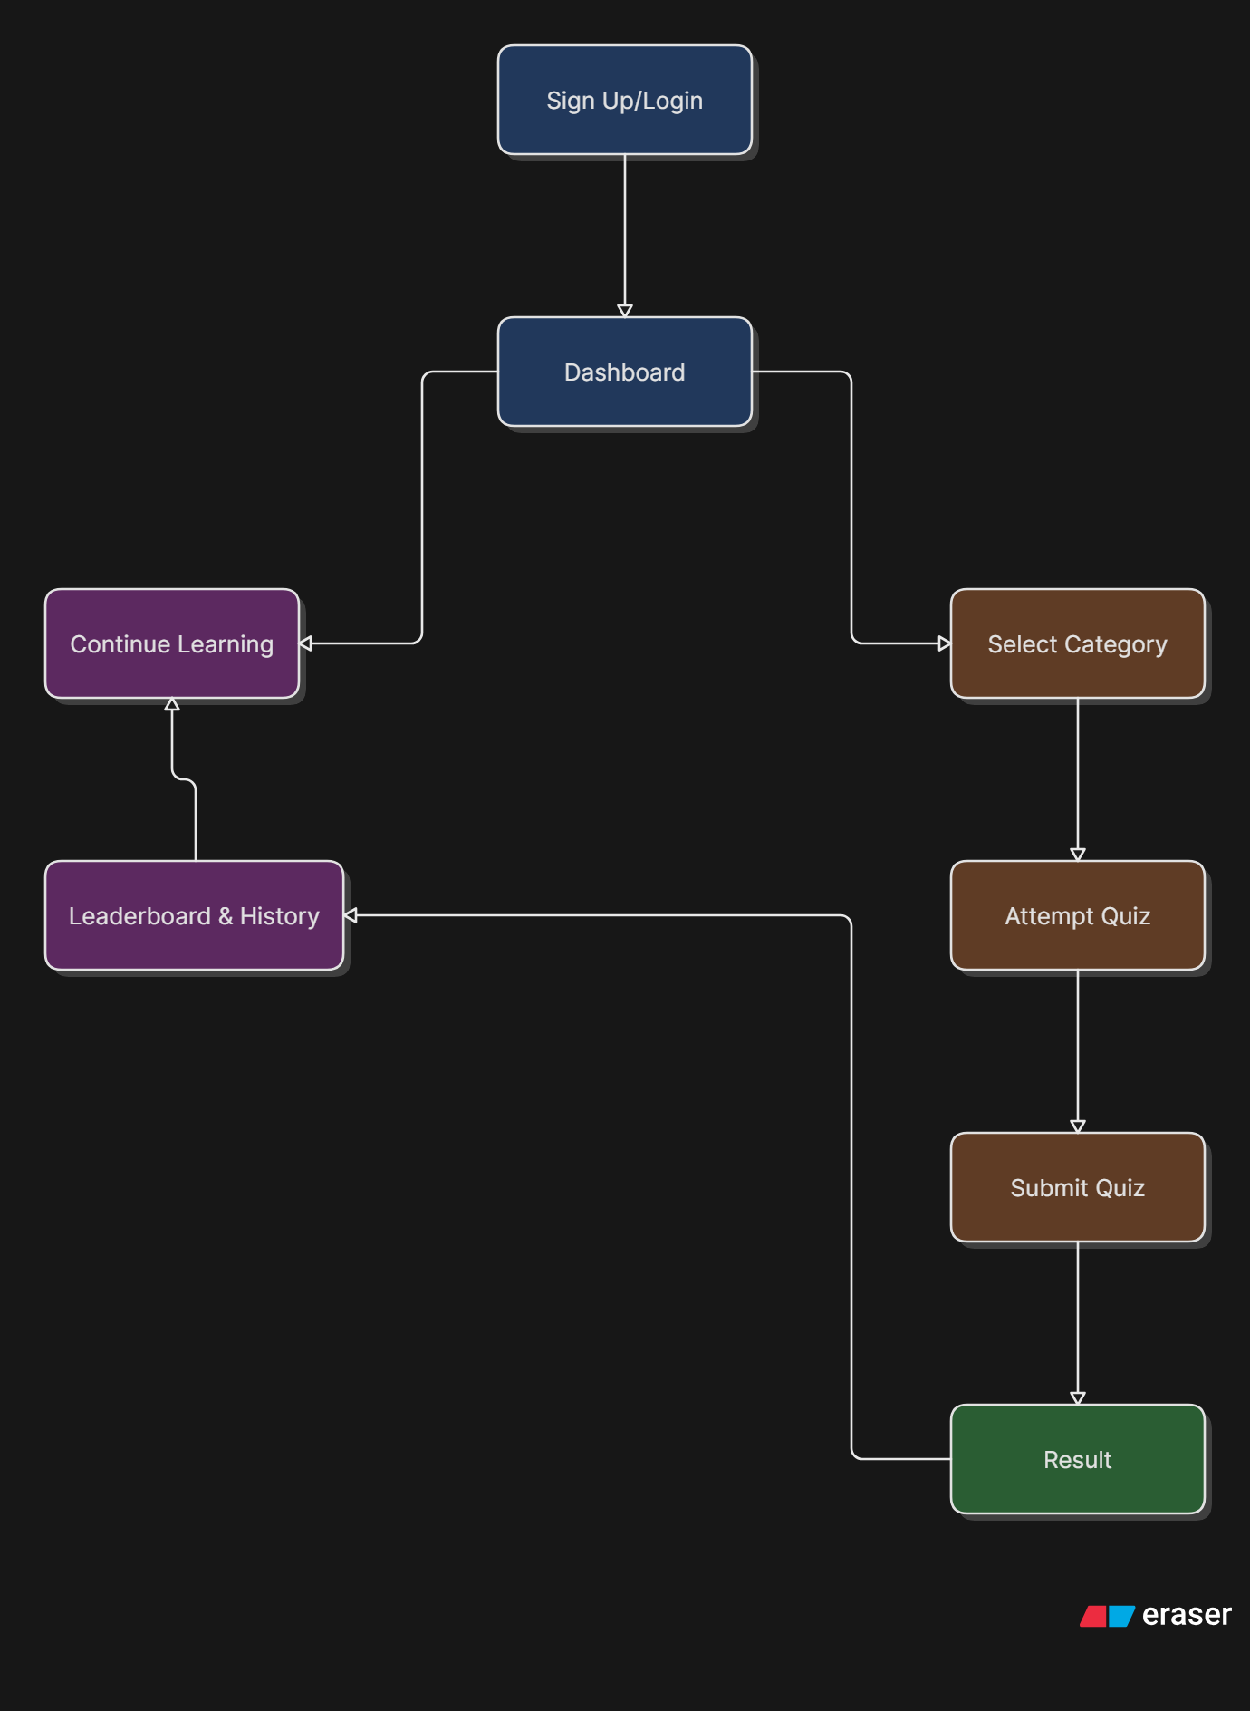

1.3 Design Models
The design models of the Quiz App for Students provide a graphical representation of the system structure, behavior, and data movement. These models help in understanding the interactions between users, system components, and databases during the execution of various functionalities. The design models are developed according to Object-Oriented Design principles to ensure modularity, maintainability, and scalability of the application.
The following design models are used in the system:
Class Diagram
The Class Diagram illustrates the static structure of the Quiz App by showing the classes, attributes, methods, and relationships between different entities such as User, Quiz, Question, Result, Leaderboard, and Admin. It provides a blueprint of the system's object-oriented architecture.
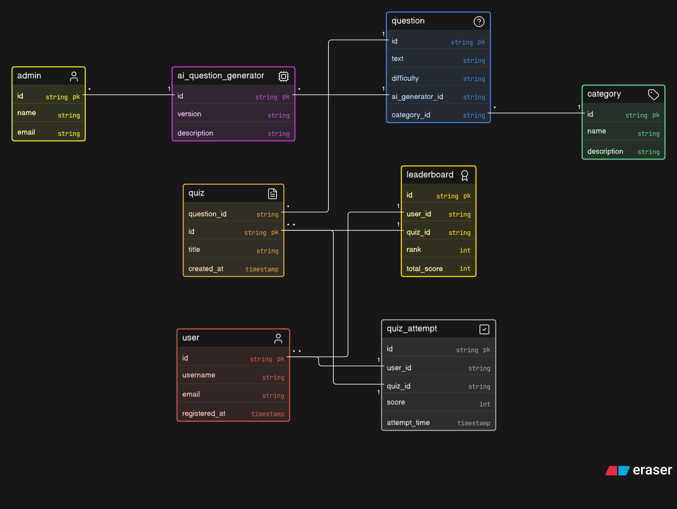

Sequence Diagram
The Sequence Diagram represents the interaction between the user and system components over time. It demonstrates the flow of messages during processes such as user login, quiz attempt, score calculation, and result generation

Timing Diagram
The Timing Diagram represents time-dependent events within the application, particularly during quiz sessions. It illustrates timer execution, answer submission, score calculation, and result display operations to ensure timely system responses.
Since the Quiz App is a software-based mobile application and does not involve dedicated hardware components, a Schematic Diagram is not applicable to this project.

1.4 Data Design
The data design of the Quiz App for Students is developed to ensure efficient storage, retrieval, and management of user information, quiz content, performance records, and leaderboard data. The system utilizes Firebase Firestore (or Realtime Database) as its primary database management system, providing secure, scalable, and real-time data access. The database structure is organized into multiple collections, each responsible for storing specific information required by the application.
The Users collection stores user-related information, including user ID, name, email address, roll number, and profile details. This information is used for authentication, profile management, and personalized learning experiences. The Categories collection contains subject-wise quiz categories such as Mathematics, English, and Computer Science, enabling users to select quizzes based on their interests or academic requirements.
The Questions collection maintains all quiz questions, answer options, correct answers, difficulty levels, and category references. These records are retrieved whenever a student starts a quiz. The Quiz Attempts collection stores information related to completed quizzes, including user IDs, scores, correct and incorrect answer counts, and attempt timestamps. This data supports performance tracking and historical analysis.
The Leaderboard collection maintains cumulative scores and ranking information for users, allowing the system to display top-performing students and encourage competitive learning. Additionally, AI-generated questions created through OpenAI integration can be stored and reviewed before being published for student use.
The database design follows normalization principles to minimize redundancy and maintain data consistency. Relationships between collections are managed through unique identifiers, ensuring efficient data retrieval and secure information management. Overall, the data design provides a reliable and scalable foundation for supporting quiz operations, user management, performance evaluation, and future system enhancements.

- Data Model Schema
The data model of the Quiz App for Students is designed to efficiently manage users, quiz categories, questions, quiz attempts, results, leaderboard rankings, and AI-generated content. The system follows a structured database model where entities are interconnected through defined relationships to ensure data consistency, secure storage, scalability, and efficient quiz processing. The database supports student learning activities, performance tracking, and AI-powered question generation.

2.1 User Entity
The User entity represents registered users of the Quiz App. It stores authentication and profile information required for accessing the system.

Attributes:
• UserID (Primary Key)
• FullName
• Email
• Password (Encrypted)
• RollNo (Optional)
• ProfilePicture
• Role (Student/Admin)
• RegistrationDate

Working Properties:
The User entity manages user registration and authentication through Firebase Authentication. It stores profile information and serves as the primary entity for quiz participation, result tracking, and leaderboard ranking. Each user can attempt multiple quizzes and maintain a performance history within the application.

Relationships:
• User (1) → (M) QuizAttempt
One user can attempt multiple quizzes.
• User (1) → (M) Result
One user can have multiple result records.
• User (1) → (1) Leaderboard Profile
Each user has a leaderboard ranking record.

2.2 Quiz Category Entity
The Quiz Category entity represents the different subjects or topics available within the application.

Attributes:
• CategoryID (Primary Key)
• CategoryName
• Description
• TotalQuestions

Working Properties:
The Quiz Category entity organizes quizzes into different subject areas such as Mathematics, English, Computer Science, and General Knowledge. It allows users to browse available categories and select a preferred subject before starting a quiz.

Relationships:
• Category (1) → (M) Question
One category contains multiple questions.
• Category (1) → (M) QuizAttempt
Many quiz attempts can belong to the same category.

2.3 Question Entity
The Question entity stores all quiz questions available in the system.

Attributes:
• QuestionID (Primary Key)
• CategoryID (Foreign Key)
• QuestionText
• OptionA
• OptionB
• OptionC
• OptionD
• CorrectAnswer
• DifficultyLevel
• SourceType (Manual/AI Generated)

Working Properties:
The Question entity maintains the quiz question bank. Questions can be manually created by administrators or generated through AI. Each question belongs to a specific category and contains answer options along with the correct answer used during score calculation.

Relationships:
• Question (M) → (1) Category
Each question belongs to one category.
• Question (M) ↔ (M) QuizAttempt
Multiple questions can appear in multiple quiz attempts.

2.4 Quiz Attempt Entity
The Quiz Attempt entity records each quiz session started by a user.

Attributes:
• AttemptID (Primary Key)
• UserID (Foreign Key)
• CategoryID (Foreign Key)
• StartTime
• EndTime
• Duration
• Status (Completed/In Progress)

Working Properties:
The Quiz Attempt entity manages active and completed quiz sessions. It records the selected category, quiz duration, start time, and completion status. It acts as a bridge between users and results while supporting performance tracking.

Relationships:
• QuizAttempt (M) → (1) User
• QuizAttempt (M) → (1) Category
• QuizAttempt (1) → (1) Result

2.5 Result Entity
The Result entity stores the outcome of completed quizzes.

Attributes:
• ResultID (Primary Key)
• AttemptID (Foreign Key)
• UserID (Foreign Key)
• TotalQuestions
• CorrectAnswers
• WrongAnswers
• Score
• Percentage
• CompletionDate

Working Properties:
The Result entity calculates and stores quiz performance metrics. It provides instant feedback by displaying scores, correct answers, incorrect answers, and overall performance. The data is also used for performance history and leaderboard calculations.

Relationships:
• Result (M) → (1) User
• Result (1) → (1) QuizAttempt

2.6 Leaderboard Entity
The Leaderboard entity stores ranking information used to compare user performance.

Attributes:
• LeaderboardID (Primary Key)
• UserID (Foreign Key)
• TotalPoints
• HighestScore
• AverageScore
• Rank

Working Properties:
The Leaderboard entity maintains user rankings based on quiz performance. Rankings are updated automatically after successful quiz submissions. This entity encourages competition and motivates users to improve their scores.

Relationships:
• Leaderboard (M) → (1) User

2.7 AI Generated Question Entity
The AI Generated Question entity stores questions created through OpenAI integration before publication.

Attributes:
• AIQuestionID (Primary Key)
• CategoryID (Foreign Key)
• GeneratedQuestion
• GeneratedOptions
• CorrectAnswer
• Status (Pending/Approved/Rejected)
• GeneratedDate
• ApprovedBy

Working Properties:
This entity manages AI-generated quiz content. Questions generated through the OpenAI API are stored as pending records until reviewed by an administrator. Approved questions are transferred to the Question entity and become available for student quizzes.

Relationships:
• AIQuestion (M) → (1) Category
• AIQuestion (M) → (1) User (Admin)

2.8 Overall Relationship Summary
The Quiz App data model follows these primary relationships:
• User (1) → (M) QuizAttempt
• User (1) → (M) Result
• User (1) → (1) Leaderboard
• Category (1) → (M) Question
• Category (1) → (M) QuizAttempt
• QuizAttempt (1) → (1) Result
• Result (M) → (1) User
• AIQuestion (M) → (1) Category
• Question (M) → (1) Category
The data model ensures efficient management of quiz activities, user performance tracking, leaderboard generation, and AI-powered question management while maintaining scalability and data integrity throughout the system.

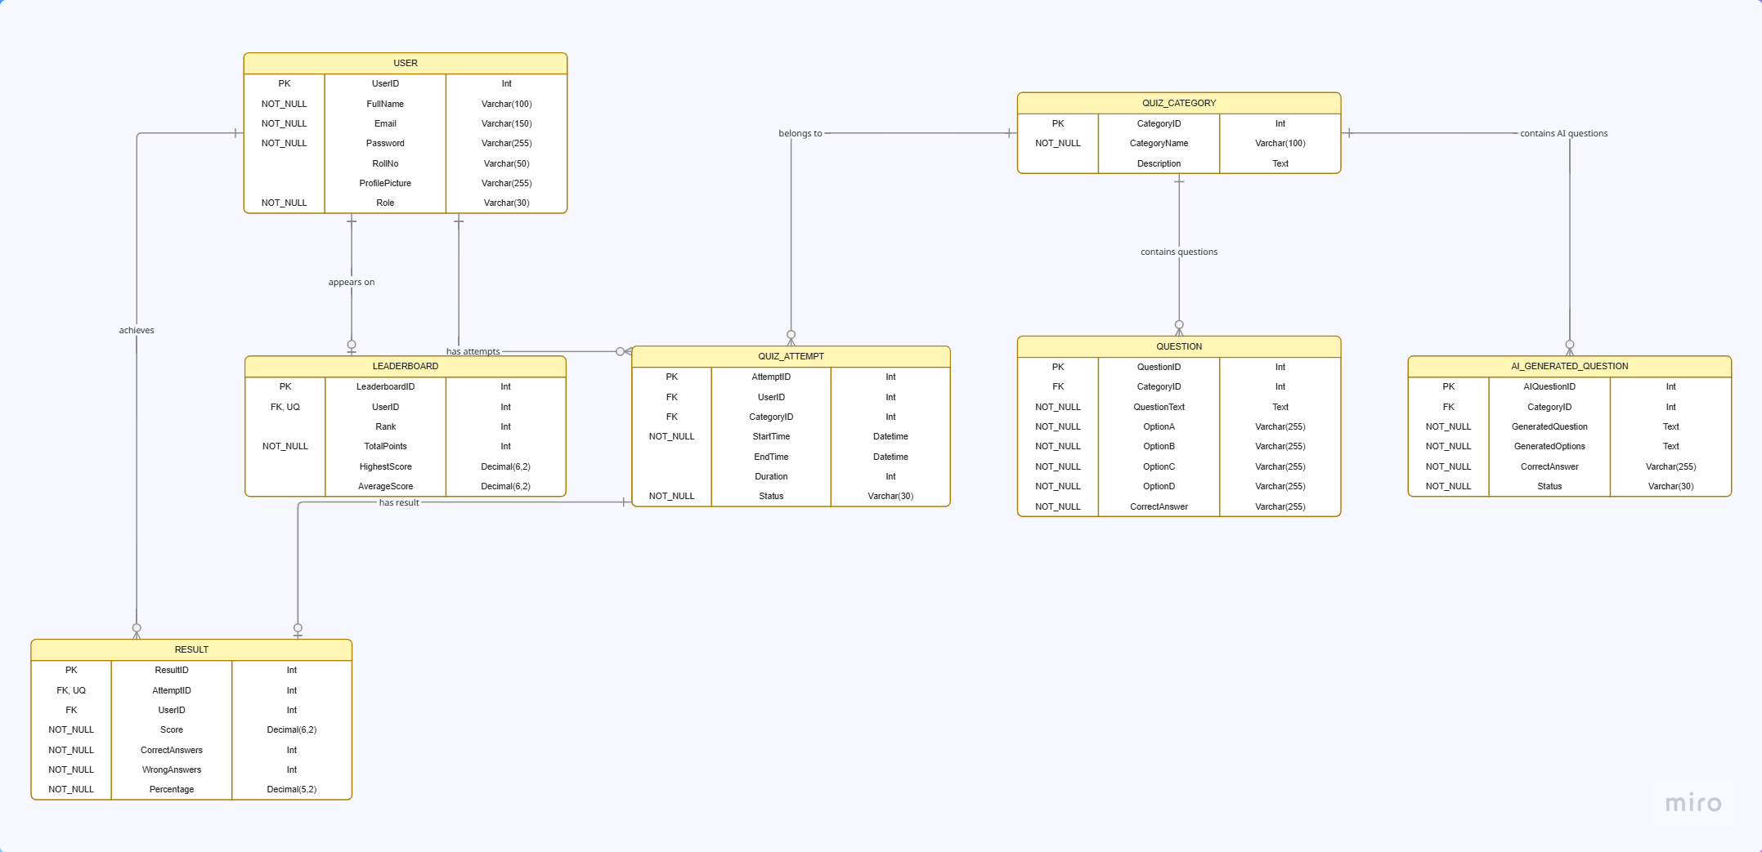

- User Interface

3.1. Design Philosophy & Niche
The design philosophy for the Quiz App focuses on an engaging, premium, and gamified educational interface tailored specifically for university students. The application utilizes a clean card-based layout with smooth micro-interactions to lower cognitive load during timed assessments. By shifting to a high-contrast palette, the layout establishes a prestigious academic aesthetic. It follows a flat visual hierarchy, minimizing complex multi-step navigation menus so that students can jump straight from the home dashboard into an active quiz session within two taps.

3.2. Visual Assets & Guide

3.2.1. Color Palette
The color scheme is meticulously selected to enhance readability, focus, and modern aesthetic value, incorporating standard university styling alongside premium gamification highlights:
- Primary Branding Color (Deep Royal Blue): Used for primary navigation app bars, dashboard background accents, and main call-to-action buttons (#1A365D). This instills professional security and academic trust.
- Premium Accent Color (Golden Yellow): Used for highlighting achievement achievements, ranking status, trophy indicators, active timers, and special premium interactions (#D4AF37).
- Neutral Canvas Canvas (Pure White & Light Ivory): Pure White (#FFFFFF) forms the background for content cards, while Light Ivory/Gray (#FAFAFA) is used for the underlying screen canvas to provide deep visual separation and contrast.
- System Metrics Colors: * Success Soft Green (#2E7D32): Highlights correct answers during review.
  - Alert Soft Red (#C62828): Indicates wrong answers, time exhaustion, or destructive actions.

3.2.2. Typography & Fonts
The font configuration relies on standard clean sans-serif typefaces (Roboto for Android platforms and SF Pro Text for iOS deployment) to guarantee fast runtime engine rendering:
- Screen Identity Headers: Bold, 24pt, Deep Royal Blue (#1A365D) for principal view identifiers.
- Quiz Category Text: Semi-Bold, 16pt, Slate Navy (#2C3E50) on card grid titles.
- Core Question Typography: Medium-Weight, 18pt, Charcoal Dark (#212121) with a 1.5 line-height coefficient index to prevent optical fatigue during intense reading intervals.
- Option Button Text: Regular, 14pt, Deep Royal Blue (#1A365D).

3.3. Responsive Layout & Screen Size Constraints
The interface layouts are engineered using percentage-based structural constraints (MediaQuery and fluid Flex grids in Flutter) targeting standard 5.5-inch to 6.7-inch mobile smartphone viewports.
- Safe Areas & Keyboard Viewports: Input frames wrap data-entry matrices in flexible scrolling list wrappers (SingleChildScrollView) to automatically push input fields upward when the virtual mobile soft-keyboard overlays the bottom workspace view, preventing layout clipping errors during registration or profile setup.
- Component Aspect Ratios: Interactive quiz answer choice buttons scale relative to width rather than fixed viewport heights, ensuring text wraps cleanly across varying device aspect ratios (e.g., 16:9, 19.5:9) without overlapping nearby UI assets.

3.4. Detailed Screen Layouts & Data Explanation

3.4.1. Sign In / Authentication View (UC001 & UC002)
This primary portal acts as the security access barrier for users. The page features a prominent educational icon mockup placeholder at the top center axis highlighted in gold, immediately followed by vertical text field input forms for email credentials and a password input. A large Royal Blue primary button triggers security checks. Directly beneath the primary action block, secondary flat text links allow users to change views to either the account registration frame or a forgot password sequence.
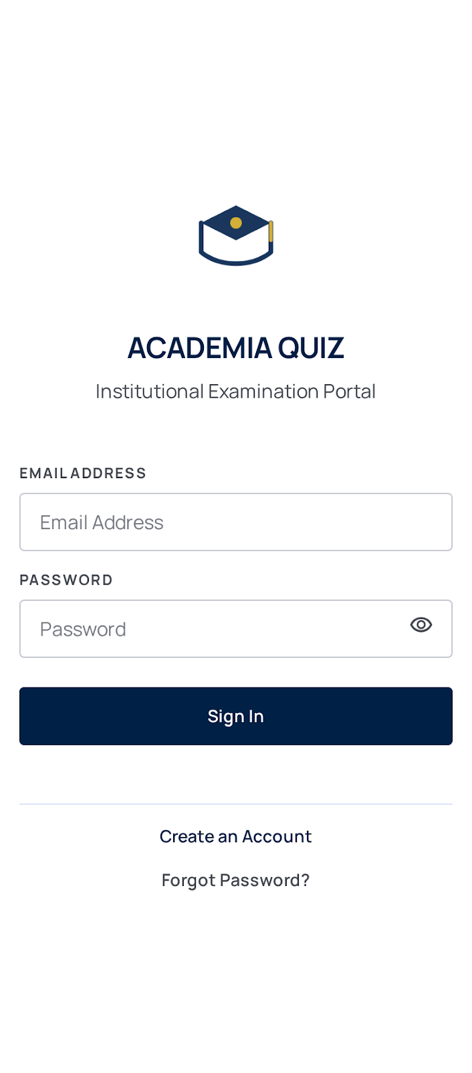

3.4.2. Home Dashboard & Category Selection View (UC003)
Once authorized, students are welcomed by a personalized profile header widget showcasing a prominent golden trophy badge containing their dynamic points score. The central canvas lists subject categories (e.g., Computer Science, Mathematics, English Literature) in a dual-column grid system of white cards. Each category card encapsulates a unique golden-accented vector illustration placeholder icon, a bold title string, and metadata detailing the total number of quiz items available. A sticky bottom navigational icon bar allows immediate switching to the History or Leaderboard tabs.
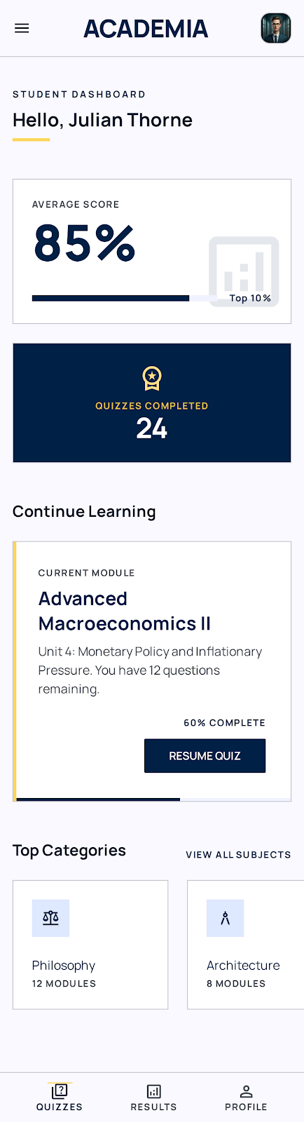

3.4.3. Active Quiz Session View (UC004)
The live interactive test screen places a golden circular countdown clock tracking execution metrics at the top center. Below the timer, a royal blue progress indicator bar visually maps the user's progress through the quiz (e.g., "Question 4 of 10"). The central white block displays the AI-generated question text container. Below the text, four independent vertical option selection blocks represent the multiple-choice entries. The bottom section includes a single wide action row containing a "Next" button, which remains locked until an option bubble is selected.
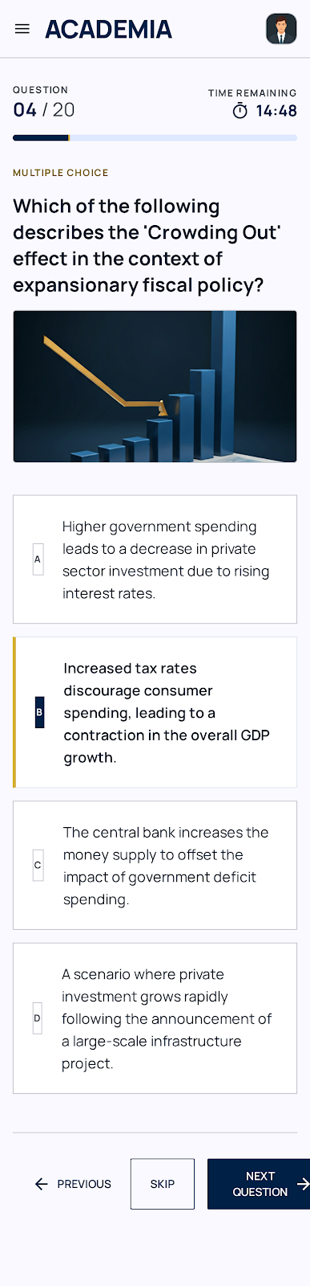

3.4.4. Quiz Result Summary View (UC005)
Upon finishing a quiz or running out of time, this scorecard template displays a summary of the student's performance. The upper third features a circular score ring highlighted in shimmering gold tracking percentage correct alongside total accrued ranking points. Below this score ring, a descriptive breakdown lists the number of correct answers, wrong selections, and skipped entries. Two full-width action buttons provide clear next steps: Royal Blue for "Review Answers" and White/Gold for "Return to Dashboard".
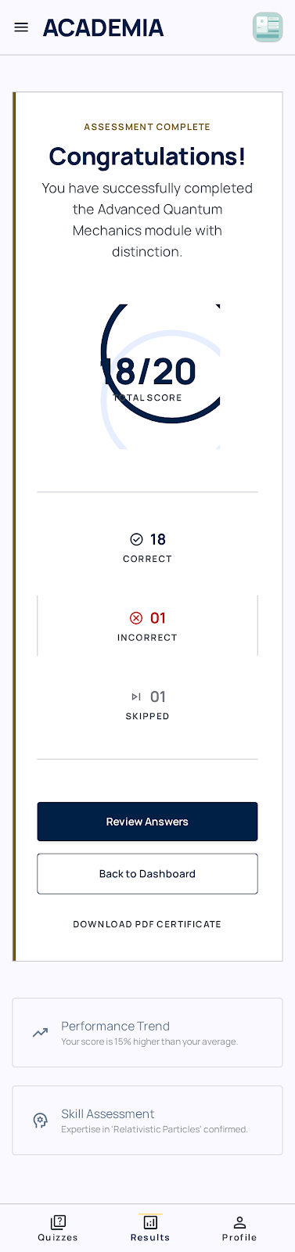

3.4.5. Quiz Review View (UC006)
This scrollable timeline allows students to review their answers for study purposes. It presents each question sequentially. The option chosen by the user is clearly marked (with a green border for correct choices or a red border for incorrect choices). If the user answered incorrectly, the correct answer is automatically highlighted in light green to provide immediate feedback.

3.4.6. Quiz Performance History View (UC007)
A tracking view that displays historical quiz attempts in a clean, vertical chronological timeline list format using high-contrast white cards over a soft background canvas. Each history row card explicitly shows the subject category title, the date of completion, the final score achieved, and the precise point metrics earned (highlighted in gold text badges) during that session.

3.4.7. Global Leaderboard View (UC008)
Designed to encourage consistent learning, this high-contrast interface features a tiered podium graphic highlighting the top three scoring platform accounts at the top, crowned in gold accents. Below the podium, the screen transitions into a dense scrolling list map indexing rank positions (e.g., Rank #4 through #100), displaying student names, avatar thumbnails, and total platform point levels emphasized with royal blue numbers.

